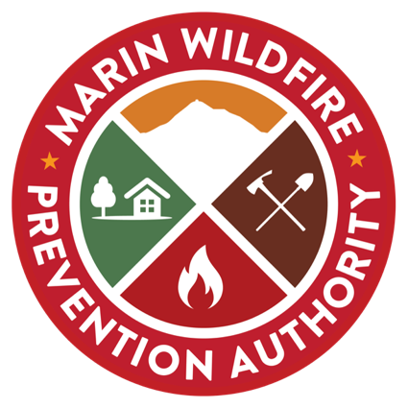

MWPA BOARD OF DIRECTORS ANNOUNCE OPENINGS ON THE CITIZENS’ OVERSIGHT COMMITTEE

Marin citizens and representatives of interest groups are invited to apply for service on the Marin Wildfire Prevention Authority’s Citizens’ Oversight Committee.

The application period closes at 5:00 pm on Wednesday, September 23, 2020. Nine (9) participants will be selected by the MWPA Board of Directors, with five (5) persons representing the Authority’s geographical area and four (4) persons representing interest groups in the following categories: Taxpayer Organizations, Environmental Organizations, Fire Prevention Organizations and Non-Partisan Civic Organizations.

Please visit www.marinwildfire.org to fill out and submit the on-line application, to upload supplemental documents and to review the duties and responsibilities of the COC. To get started, and for ease of reference, use this link:

Click here to open the COC web application.

Questions?
Contact: Jean Bonander, Interim Executive Officer
jeanbonander@sbcglobal.net
415-794-7333

Mariya Weinberg, Administrative Analyst
adminaide@smfd.org
(415) 388-8182

